Save the Date
New England Ringers
In concert at
Franklin Federated Church
Saturday, November 24, 2018
Tickets-$15
A Few of Your Favorite Things
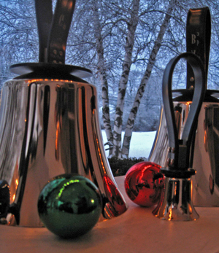
Ticket sales begin November 4, 2018

Franklin Federated Church’s Annual Christmas Concert
New England Ringers
Saturday, November 24
Sponsorship Form
Business Name:________________________________________________________________________________________
Address:_____________________________________ State:_______________ Zip:________________________
Contact Name:________________________________________________________________________________
Email:___________________________________________________ Phone:__________________

Dear Sponsor,
All sponsors will receive recognition in the concert program, on the church website and on the church Facebook page. Please include the address where your complimentary tickets should be mailed, if different from the one listed. Checks should be made out to Franklin Federated Church.
Please mail/drop off donations to: Franklin Federated Church, 171 Main Street, Franklin, MA 02038
Attention: Christmas Concert Team
Sponsorship Levels
Platinum Bell Sponsor $150.00 (4 Complimentary Tickets)
Gold Bell Sponsor $125.00 (3 Complimentary Tickets)
Silver Bell Sponsor $100.00 (2 Complimentary Tickets)
Brass Bell Sponsor $75.00 (1 Complimentary Ticket)

SPONSOR LEVEL: _____________________________
AMOUNT ENCLOSED: _______________________
To guarantee inclusion in the printed materials, sponsorship forms much be received by November 21, 2018. Please enclose this form with your business card and check.
Franklin Federated Church is a registered non-profit organization.
Thank you for supporting the Franklin Federated Church Christmas Concert.

